- How many loans in the MBS pool at issuance time?
24 loans
- What is the weighted average and range of mortgage rates at issuance time?
WAC = 4.869%; mortgage rates range from approximately 4.25% to 5.50%
- What is the coupon rate that investors will receive?
4.00%
- Who are the mortgage loan sellers?
The mortgage loan sellers are various approved lenders and originators that sold the loans to Fannie Mae, such as banks and mortgage companies (specific sellers can be viewed in the "Allocation" and "Collateral" tabs)
- What are the roles of Fannie Mae for this MBS Pool?
- Guarantees timely payment of principal and interest
- Securitizes the mortgage loans into UMBS
- Standardizes disclosures
- Provides liquidity to the secondary mortgage market

- (0.5 points) Sample Agency MBS Pool actual cashflow payment history and prepayment performance history (See the attached Excel file named “Sample MBS actual paydown FN_BJ97911_MTGE PDI.xlsx” for details). The MBS pool was issued in Sept 2019 with MBS coupon of 4.00% and issuance pool balance of $ 3,096,516.00. (0.5 points)

There are four tabs for this problem.
  - Tab #1: #1 Summary
Date, Coupon, WAC, WAM, WALA, 1M CPR, 3M CPR, 6M CPR, 12M CPR, Factor, Balance (standard MBS metrics for summary performance).
  - Tab #2: #2 MBS Pool PAYDOWN history
Date, Factor, Coupon, Principal, Interest, Balance, Cashflow
  - Tab #3: #3 Collateral history, and
Date, Factor, # Loans, WAC, WAM, WALA, Balance, Total Principal, Sched, Unsched
  - Tab #4: #4 Performance
Date, 1M/3M/6M/12M/Life for CPR, VPR, Buyout CPR, PSA

Question 2-1: Study and understand each column of all the four tabs. Write down the columns you do not understand, if any.

Question 2-2: Compare the MBS pool balance in Tab #2 Column F “Balance” and MBS collateral balance in Tab #3 Column G “Balance” for the whole history. Are the balances the same for the two tabs? And why?

The balances are the same for all months in the history.
Why? The MBS balance represents the outstanding principal of the underlying mortgage collateral pool. In agency MBS like Fannie Mae's, the securities are pass-through, so the MBS balance directly corresponds to the collateral's outstanding principal balance, adjusted for payments and prepayments.

- (0.5 points) Sample Agency MBS Pool projected cashflow payment and prepayment performance by Bloomberg (See the attached Excel file named “Sample MBS Projected Cashflow.xlsx” for details). The MBS pool (CUSIP 3140A02B4) was issued in Sept 2023 with MBS coupon of 5.50% and issuance pool balance of $ 12,852,744.00. There are seven tabs for cashflow projections for seven interest rate and prepayment speed scenarios:
  - -300 MED
  - -200 MED
  - -100 MED
  - 0 MED
  - +100 MED
  - +200 MED
  - +300 MED

Question 3-1: Study and understand each column of all the four tabs. Write down the columns you do not understand, if any.

Question 3-2: Calculate weighted Average Life (WAL, or AL) in years for each of the seven scenarios and identify the patterns in relation with scenarios.
- 300 MED: 2.53 years
- 200 MED: 4.25 years
- 100 MED: 8.15 years
0 MED: 9.89 years
+ 100 MED: 10.90 years
+ 200 MED: 11.57 years
+ 300 MED: 12.03 years

Question 3-3: Draw the projected cashflow time series for each of the seven scenarios in a single Line Chart. Describe the patterns you observe.

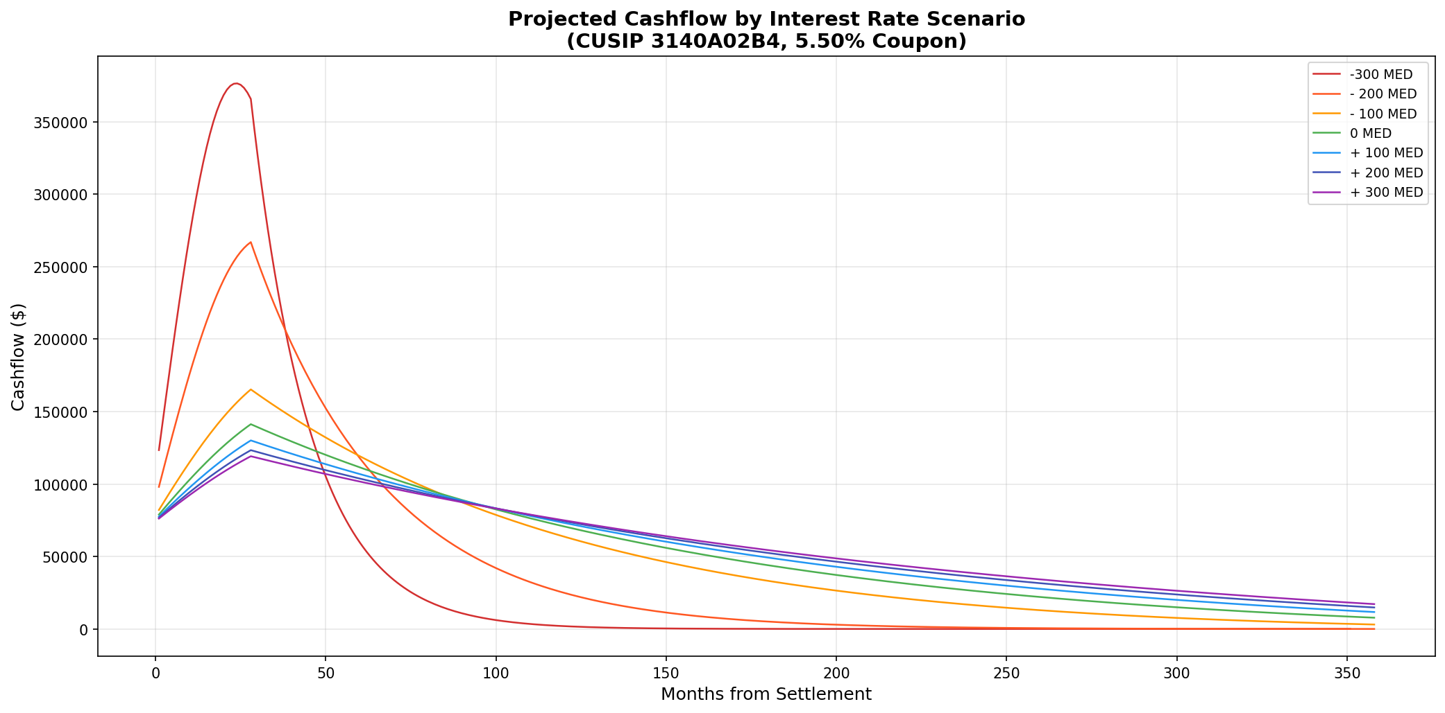

Patterns:
- 300 MED: highest early cash flows, terminates earliest
+ 300 MED: lowest, most stable cash flows over full term
Lowest-rate scenarios show a prepayment “hump”; higher-rate scenarios show flat amortization profile

- (0.5 points) In a sample OAS Analysis for the sample Fannie Mae MBS pool as shown in the following Bloomberg screenshot
Question 4-1:
- In the Static Analytics part, find the value of “Price”,
In the Static Analytics part, the value of “Price” is 100
- In the OAS Analytics part, find the values of “+25bp Px” and “-25bp Px”
In the OAS Analytics part, the values of “+25bp Px” is 99.5 and “-25bp Px” is 100.5

Questions 2-2:
- Use the Effective Duration formula to estimate the Effective Duration or OA Duration;
Effective Duration = [(Px_{-25bp} - Px_{+25bp}) / (2 * Price * 0.0025)]
- Compare your estimated duration value with the “OAD” in the OAS Analytics part.
Effective Duration = [(100.5 - 99.5) / (2 * 100 * 0.0025)] = [1 / 0.5] = 2.

- Are they the same or different?

They are the same

